lab ASSIGNMENT A12.6

Parallellines

Background:

In this lab, you will practice using nested for loops to recreate this image using the DrawingTool class:

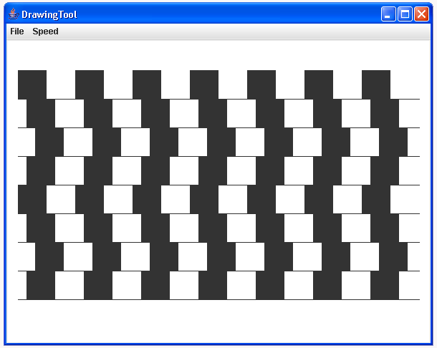

To do this efficiently, there are a few suggestions to consider. First, there are eight rows each containing seven filled boxes. This suggests a nested for loop, like this:

for (int row = 0; row < 8; row++){
// calculate the start of the row of squares

// calculate and add a horizontal offset

for (int col = 0; col < 7; col++){
// draw the square
// calculate and position for the next square
}

// calculate the location and draw the line
}

Calculating the square position will take some work. You might want to make a quick sketch, with coordinates, to save frustration. Hint: there will be a negative x offset and a positive y offset to have the image start in the upper left corner as shown.

The DrawingTool class includes a method for drawing filled rectangles:

fillRect(double width, double height)

For instance, with a DrawingTool called pen, the call pen.fillRect(40, 40) would create a 40x40 filled square centered about the current drawing position.

Assignment:

1. Using the information given in the Background section above, write a class using nested for loops to display the image shown above.

